Woodpecker Farm

**2024**

**Horse Show Series**

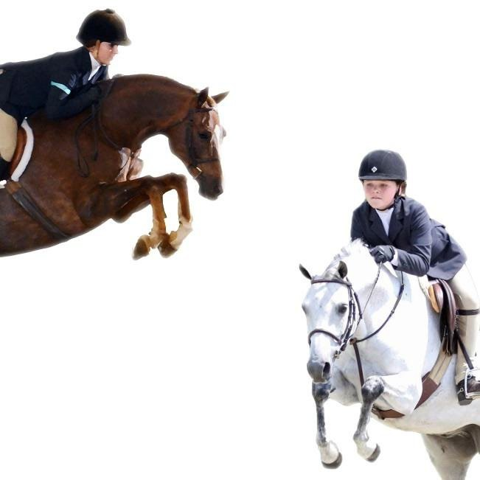

***April 27th,***

***June 1st,***

***Sept 21st,***

***Oct 25th***

*Kevin Freeman*

*Dede Bache-Shumate “Costume Class"*

Show Manager - Beth Linton [**www.woodpeckerfarm.com**](http://www.woodpeckerfarm.com/)

(540)623-5581 11321 Paige Rd. Woodford, Va 22580

Start time 9:00 A.M

* **18” Schooling until 8:45**

1. California Warm-up (course B)
2. Leadline
3. Pre-Short Stirrup Walk (leadline may x enter) BHSA
4. Pre-Short Stirrup Walk - trot
5. Pre-Short Stirrup W/T w/ tests
6. Short Stirrup Equitation W/T BHSA
7. Short Stirrup Equitation W/T/C
8. Short Stirrup Equitation over fences
9. & 10 Short Stirrup Hunter O/F

11. Short Stirrup Hunter W/T/C VHSA

12 Long Stirrup Equitation W/T BHSA

1. Long Stirrup Equitation W/T/C
2. Long Stirrup Equitation O/F
3. X-rails hunter W/T
4. X-rails Hunter O/F
5. X-rails Hunter O/F
6. Student Equitation W/T/C
7. & 17 Student Equitation O/F
8. Pleasure Pony W/T
9. Pleasure Pony Go as you please
10. Pleasure Pony Command Class

# *Pony Hunter Schooling break (not to start before 11:00)

1. & 22 Pony Hunter O/F
2. Pony Hunter U/S
3. Pony Equitation
4. & 26 Green Pony Hunter
5. Green Pony Hunter US

# Schooling Break (not to start before 12:00)

1. Equitation on the flat
2. Pleasure Horse W/T
3. Pleasure Horse Go as you please
4. Pleasure Horse Command Class
5. & 33 Limit Hunter O/F
6. Limit Hunter U/S
7. & 36 Low Hunter O/F
8. Low Hunter U/S
9. Maiden Hunter W/T
10. & 40 Maiden Hunter O/F

# *Schooling Break (not to start before 2:00)

41. & 42 Schooling Hunter O/F

1. Schooling Hunter U/S
2. & 45 Green Hunter O/F
3. Green Hunter U/S
4. & 48 TB Hunter O/F
5. TB Hunter U/S
6. & 51 Working Hunter O/F
7. Working Hunter U/S
8. AA/Children’s Equitation

54 & 55. AA/Children’s Hunter

56. AA/Children’s Hunter U/S

**Leadline: BHSA** Open to children 7 years and younger . no cross-entry into classes where they trot. **Pre-Short Stirrup Equitation: BHSA** Open to riders 10 years and under. Riders not allowed to cross enter into classes where they would be asked to canter or jump.

**Short-Stirrup Equitation: BHSA** Open to riders 12 years and under. Jumps may not exceed 18”. Riders not allowed to cross enter into classes where they would jump over 18”.

**Short-Stirrup Hunter: VHSA**Open to riders 12 years and under. Jumps may not exceed 18”. Riders & horses no cross entries into classes where jump higher than 18”. No rider may show more than 2 mounts.

**Long-Stirrup Equitation**: Open to riders 13 years and older as of December 1 of the current show year. Jumps may not exceed 18”. Riders not allowed to cross enter into classes where they would jump higher than 18”. Courses may be trotted.

**Student Equitation:BHSA** Riders in their 1st or 2nd year of showing @ 2’ or higher.

**Limit Rider Hunter**: BHSA Open to horses and ponies ridden by Juniors and Adult Amateurs who are not entered in any classes jumping 2’6” or higher.. Ponies must be ridden by juniors. . Courses to be a min. of 6 fences set at 2’3”.

**Maiden Hunter: BHSA** Horses or ponies in their 1 showing st year of showing@ 2’ or higher **Green Pony Hunter:** Ponies ridden by jrs. @ 2’ or higher 2’ small, 2’3 med, 2’6 large **Green Hunter:** Horses in their 1st year of showing @ 2’ or higher

**Low/Schooling Hunter: BHSA** Horses and ponies, riders choice 2’3, 2’6, 2’9

**Pony Hunter:** Open to jrs on ponies. Sm ponies 2’, Med jump 2’3”, large jump 2’6”

**TB Hunter:** Open to registered TBs and horses eligible to be registered. Fences 2’6”. Thoroughbred Hunter may only be combined with the Working Hunter and the Green Hunter.

**Children’s/Adult Amateur Hunter**: Open to juniors and adult amateurs. 2’6. BHSA,VHSA **Pleasure Pony**: Open to Jrs on ponies. judged on manners,suitability,soundness,way of going. **Pleasure Horse:** Open to horses. To be judged on manners,suitability,soundness,way of going.

* Woodpecker Farm employees/associates will not be held responsible for loss,accident,injury at any show to any exhibitor,spectator,groom,property or animal. Participants/spectators understand that horses are inherently dangerous and that equipment and ground conditions are equally unpredictable; and knowingly choose to participate and/or spectate, take full responsibility for this choice Entry onto the show grounds constitutes agreement and knowledge thereof.

**Pre-entries $18, Post Entries** $20 a class. $15 office fee, Non showing fee $25 for the day.

**Rules**

1. No dogs allowed
2. Negative coggins within the last 12 months required
3. ASTM approved helmets most be worn at all times while mounted
4. $50 fee will be charged for all returned checks
5. Proper riding attire, required.

**Directions** From F,burg - 95 or Rt 1 South to Thornburg. Off 95 ramp take right then left at the light,(rt.1 south). Go 3 miles. Left on Paige Rd. (Rt. 605) Go 4.8 miles. Farm on Left.

From 301 South or Bowling Green - Take 301 business to The intersection of Main St., Rt. 301 and F,burg Trnpk. Take F,burg Trnpk (Rt 2)) north .3 miles to Paige Rd. Take left go 6.4 miles. Farm on the right.

From Richmond – DO NOT get off at Carmel Church exit.. GPS takes a road that’s not horse trailer friendly, 95 north to the Ladysmith exit. Left off ramp to the 1st light. Take right on Rt.1North. Go about 7 miles to Paige Rd.. Take Right. Go 4.8 miles. Farm on Left.

11321 Paige Rd. Woodford, Va. 22580

Email [beth@woodpeckerfarm.com](mailto:beth@woodpeckerfarm.com) with all inquiries or pre-entries